**STORAGE AND PERMISSIONS**

**Q 1 : What is the Internal and External Storage ?**

**Ans 1:**

**Internal Storage** -

The Internal Storage is actually divided into 2 sub spaces -   
  
**1) Core Internal (System)** -   
  
- In lay-man terms, this memory available to you for installing your applications (Especially ones crucial to the Operating system) and data. Applications are installed in this storage and your personal data such as text messages, contact lists, your E-mail settings and the likes are stored on this.

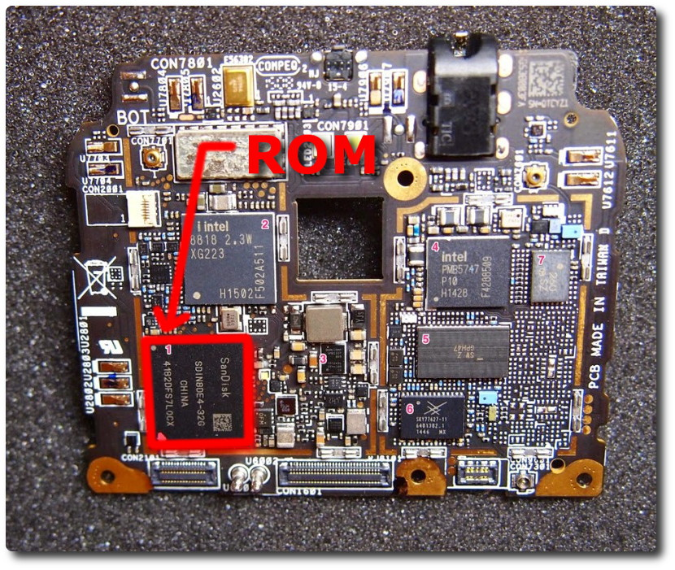

- This space is considered generally to have sensitive information and, is not accessible to you, unless root  
- You might have noticied that the box says its got 32 GB of ROM, and all you see is 25GB of available space, this is the other remaining space you never see and that you can never use.

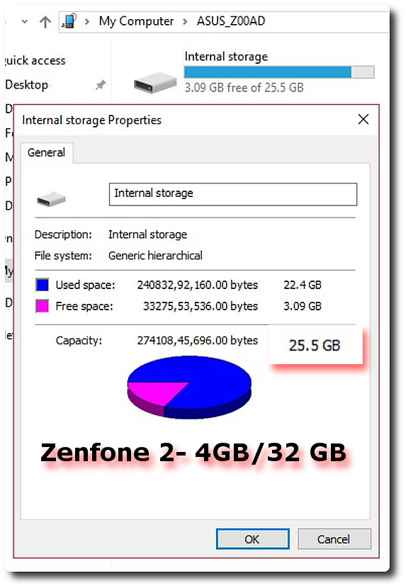

- Whenever you reset to your factory settings, all this storage gets erased. This memory is reserved for your operating system and personal data only. It will never show up whenever you connect your device to the computer.

**2) Phone Storage** -   
  
- This is the part of the Internal storage that is actually available to you (25GB as shown above in the screenshot).

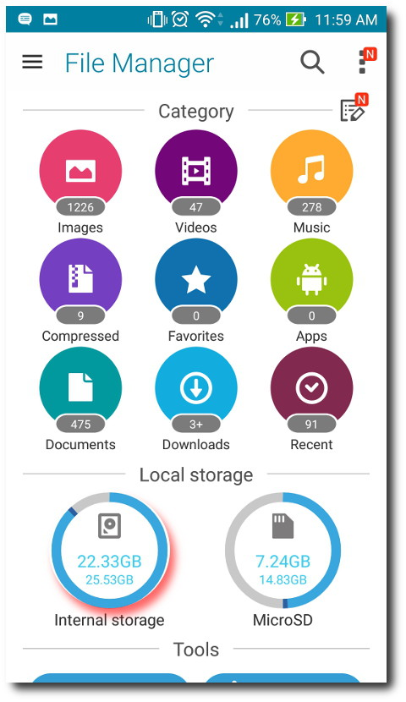

- This is the space where your games and applications are installed and it is the default memory for storing your pictures, movies, songs and so on. You can access it when you connect your device to the computer.  
  
**- Internal Storage in General :**- The Internal Memory is faster than an external storage, you can verify this when you see the write-speed differences when copying a large file to either memory.

- The OS is able to read & write to memory with very highspeeds. the faster this memory is, the faster your Android Experience (depends on the amount of RAM too).

**External Storage** -  
  
- As the name suggests, this is the external 'Expandable' storage capacity of your phone. It depends on the compatibility of the memory card slot and to what extent is it supported.

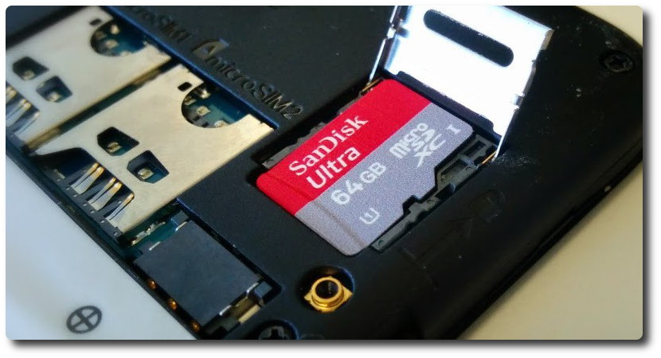

- In simple terms, this storage can be removed physically off of the device and can be replaced and re-used.   
- It is generally used for storing pictures, music, videos, and very large-sized games (if possible), and the likes.  
- Although, you may or may not be able to install most applications on it, and that totally depends on the App developers, and even the manufacturer.  
- A new kind of external 'Auxilary' storage mechanism is the OTG support, with this you can use USB 2.0 storage devices (rated at 5v @ 500mA, and not more) by directly porting it to Micro USB charging/data port on your phone using an OTG cable.

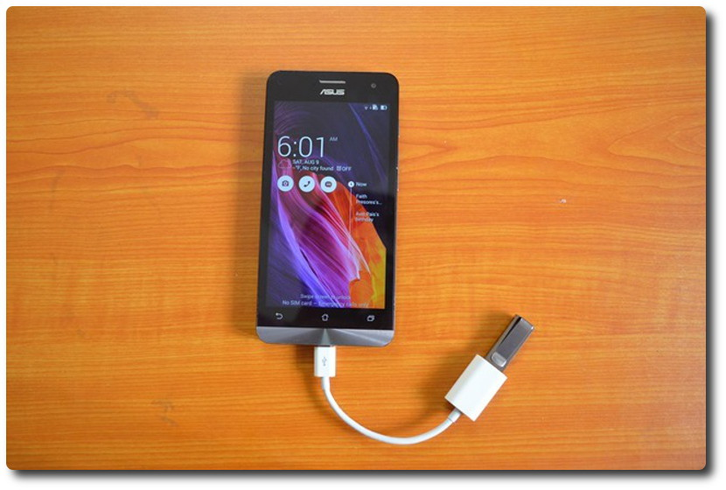

- Generally external storages are slower than the Internal Storages, and putting large essential apps on this will have serious performance bottlenecks, if you're continually multitasking with it.- To get rid of Performance bottlenecks, invest in a Class 10 SDXC Micro-SD cards, with atleast 32 GB and Up to be future-proof  
  
**Here are the common questions that arise in the difference** -   
  
1) Can you/Should you at all move Apps to the SD-Card???  
  
- There are actually 2 reasons: The obvious one is because your storage is full and you need storage space. The other time when you need to do so is, when you want to speed up your phone.   
- On the Zenfone with Android 5.0, you have a tab section in App Settings called Movable. App listed under it can move its data to the External Storage.

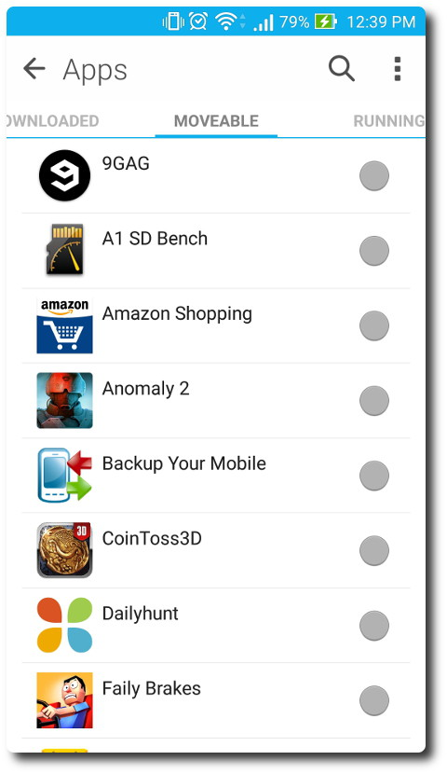

-The Internal NAND Flash storage (and even SD Cards) when full or nearly full, takes more time and energy for the Memory Controller to track where your data is stored. So, it is advised that if possible, the non critical and huge apps like games can be stored on the External memory.  
- So in order to enjoy good performance, you should keep at least 20 percent of your storages free at all times.  
  
2) But Why does the Apps have limitations when copying/installing to the External Memory???  
  
- Not all apps can be transferred to your SD-card. Only If developers check the ‘Apps2SD’ option in their app can you can move that App to SD card.   
- Another important thing is that a complete app will not move to SD card. For eg. If you move 25 MB wide Adobe Flash Player to SD card, you only are able to free up 8 to 10 mb of space on the internal memory.

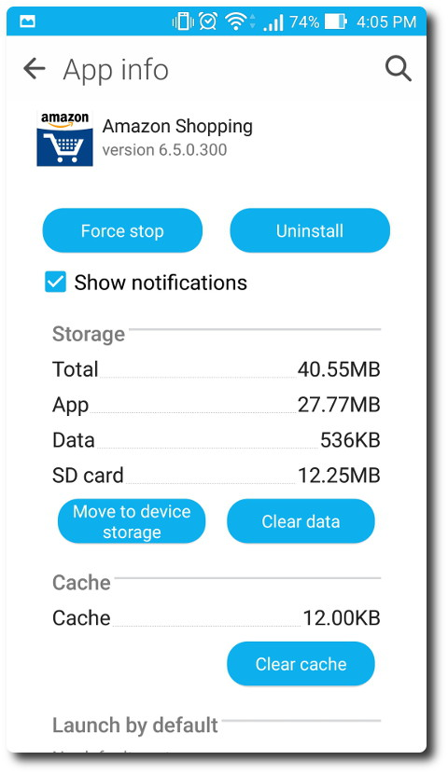

- Everything that you need to run when your SD card is not on your phone, including important system apps and widgets, has to remain on your phone and thus you can’t transfer them to SD card.   
- Also, you cannot transfer preloaded apps ASUS apps to SD card. The situation varies with different devices. Many other manufacturers don’t let you move Apps to SD card for security and performance reasons.

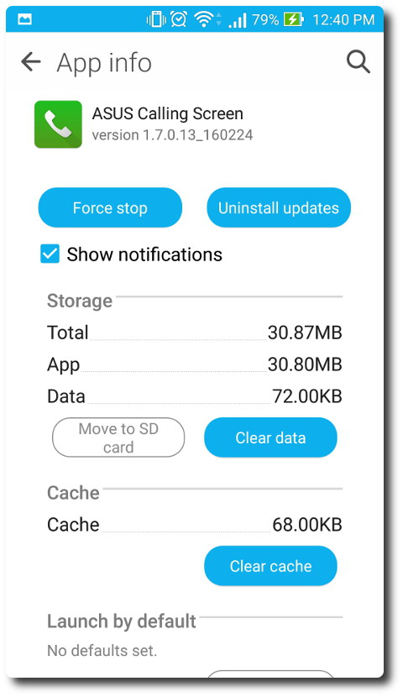

- To get everything to the SD-card, one needs to have root access, but the dangers are that if an system essential app is tranferred to the SD, the system won't be as responsive as before. System stability is as important as performance and security.  
  
3) How to fix the insufficient storage issues ???  
  
- Once you have a nearly full Internal Space, the first thing you have to clear is the Individual App Caches, these are cache or temporary files that an App leaves behind once it completes certain active operations.

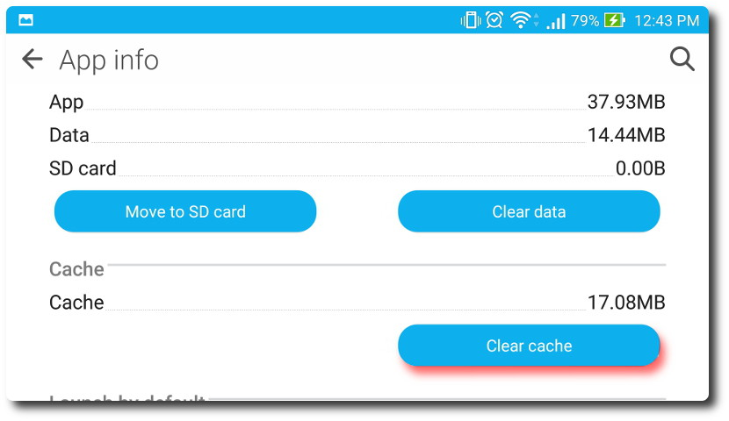

- You can automate the Cache deletion by using the in-built CleanMaster App, else you have to delete specific caches individually under the App settings page.

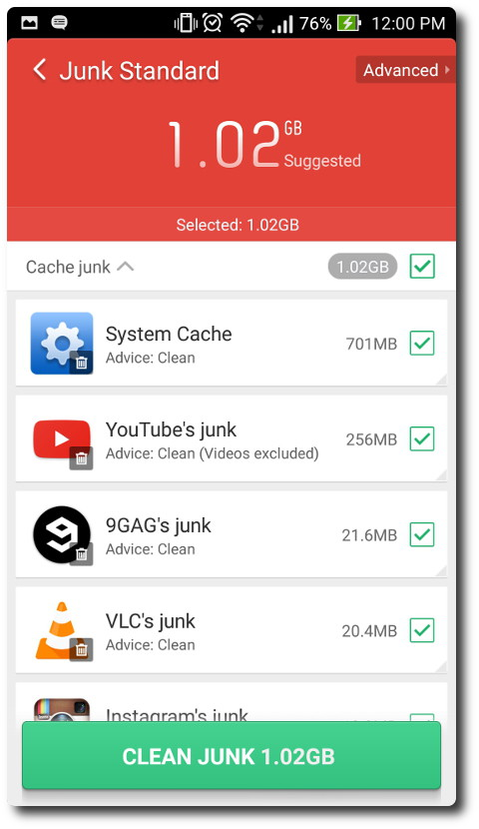

- You also can review your storage composition by going to the Storage options under Settings.

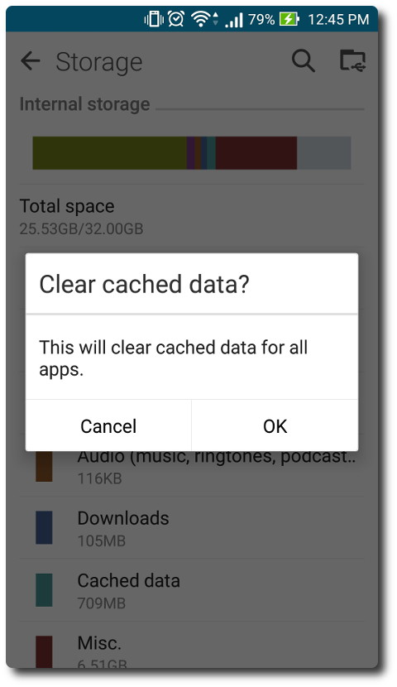

- Delete all uncessary downloaded content under the Download folder.   
- Backup Photos with the Google Photos App, this will free up alot of space, as each Camera pics may be as large as 5-6 mb.

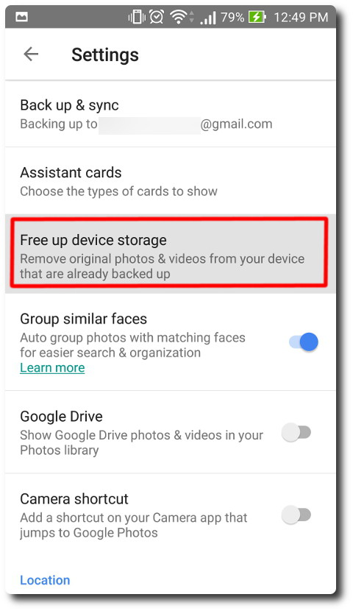

- Backing up whatsapp media files also helps, Whatsapp lets you Back up everything onto Google Drive as well.  
- Only keep Apps that you actively need, having a huge collection of Apps maybe impressive, but your system space maybe already bulking with all that data.

**Q2 : For How long data resides in cache?**

**Ans 2 :**

The cache memory is only a few megabytes in size, so it contains only a part of the process you’re currently running. When you’re using Chrome, that will be some Chrome data indeed. But once you stop, or even just switch to another running program, it will be removed.

When Chrome is active, it will be stored in your RAM, which has a similar function to cache. Then as you switch back to Chrome, it’s loaded into cache more quickly. When you don’t have any other open programs, Chrome may remain in RAM even when you shut it down. On the same note, if you have lots of other programs, Chrome may get swapped out of RAM even though it’s still active.

So, in conclusion cache memory is used for faster retrieval of data and reduce the latency and speed of accessing the data. It is removed from cache as soon as application is shifted to stopped.

**Q3 : What are Critical permissions and Normal permissions? Give examples of both.**

**Ans 3 :**

**Critical permissions,** These are those permissions which can harm your phone when given the chance. Modern day Phones and gadgets are so powerful that they can also be harmful at the same time.

Permissions are special privileges that apps must ask if they want to access sensitive media on your phone.

**Normal permissions,** These permissions do not cause any harm to your phone and are basic permissions which must be allowed to perform day to day activities of the phone.

They are not cause any potentially threat and do not require special privileges to access sensitive media on your phone.

Ex: Critical Permission, READ_CONTACTS.

Ex: Normal Permission, ACCESS_WIFI_STATE.